Kenaf Fibre Reinforced Polymer Composite – Effects on size, orientation and Modification on Composite Properties

Muhammad Abu Bakar

Department of Mechanical, Materials & Manufacturing Engineering, University of Nottingham Malaysia Campus, Semenyih, Malaysia

ABSTRACT: The purpose of this project was to study the effect of fibres size, orientation and modification on the composite properties. The fibres size was referring to fibres thickness or its diameter. Fibres size that be used in this study were in three different size, less than 125$μ$m, greater than 125$μm$ and flour form. Optimum fibres size will increase impact strength of the kenaf fibres (Yousuf A. E., 2011). In order to achieve the best orientation, 3 type of direction were used, unidirectional with continuous fibres, unidirectional with discontinuous fibres and random distribution of fibres. The best orientation was unidirectional with continuous fibres length, it gave maximise tensile properties. In order to improve and enhance composite properties, kenaf fibres raw materials were immersed in Sodium Hydroxide (NaOH) with certain amount concentration. There were three type of concentration of NaOH will be used. 4%, 5% and 6% of NaOH concentration were used and this process was done before manufacturing process. The best NAOH concentration gave the maximum value if tensile modulus (O.M.L. Asumani, 2012). The kenaf fibres reinforced composite (KFRC) was manufactured by using lay-up process without any external or internal pressure and a mould was used to fix its dimension. A few testing method were used in order to determine KFRC properties. The testing involved in this study were tensile, impact, bending, water absorption, water degradation, soil degradation and it microstructure is observed by using scanning electron microscopic (SEM).

Introduction
Kenaf plant was one of the best natural fibres be can be used in fibres reinforce polymer composite. The fibres were extracting from the bast of the plant and it was widely used as a jute-like material and as reinforced in polymer composite. Kenaf plant was one of the low-cost fibres with low density and high specific properties. It was biodegradable, eco-friendly and non-abrasive. Kenaf plant also readily available in market and their specific properties were comparable to other fibres used for reinforcements. Kenaf fibres reinforced polymer composite were widely used in industry worldwide to replace some metallic structure and exploited as a replacement for conventional fibres such as glass, aramid and carbon due to its composite properties. It was known to have higher mechanical properties. Tensile strength of kenaf fibres have been testified in (Ramaswamy G. N., 1995). It tensile strength and tensile modulus of 11.91 GPa and 60 GPa. Kenaf fibres have been used widely as reinforcement in the thermoplastics and thermosetting in polymer composite (Dansiri N., 2002). Tensile properties of fibres reinforced polymer were depends on the interfacial adhesion between the matrix and fibres.

Fibre reinforced polymer composites (FRPC) has a significant advantage over metallic material under corrosive environment due to their high corrosion resistance against corrosion agents such as water, hydrogen and oxygen (Zampaloni et al., 2007) ( Serizawa et al., 2006). Natural fibres was much cheaper than synthetic and can be used to replace synthetics in many application which can saving money and weight composites performance (Oksman K., 2003). Kenaf fiber was used to as reinforcement material for polymer composite as alternative to glass gibers. When compared to in organic fiber, it shows a lot of advantage such as low density and cost, non-abrasive during process and to processing equipment, harmless, renewable, biodegradable, recyclable and easily available (George J., 2001) (Li Y., 2008). Therefore, it has a potential of replacing metal-based component, profile or structural member in the environment where corrosion is the main problem of nature (Fowler et al., 2006, Bakis et al., 2002).
Fibres size that used in composite polymer clearly affects mechanical properties of the composite(Lai et al., 2005) (Yousuf A. E., 2011). The impact strength showed a slight increase trend with an increase in fibres size. Thus, mechanical and tensile properties was depends on size of the fibres. The larger the fibres size, the higher mechanical properties due to many gap and hole on composite (Jamaludin, 2008) and it can absorb more water.

Fibres orientation in KFRP was important for the improvement of properties for polymer composite achievement in this study (Zampaloni et al. 2007). It was not surprised to found that orientation state varies from point to point within elements due to fibres orientation was determined by characteristic of flow during moulding. However, stressed was one of the main problems that need to be addressed in the manufacture of kenaf fibres reinforced composites regards uneven fibres distribution (M. Zampaloni, 2007). Strength of the mould elements was determined by materials where the orientation state of minimum coincides with maximum stress (R. Byron Pipes, 1982). It is state that to control its orientation was nearly impossible but its alignment was fix in unidirectional. Besides that, the stiffness of a composite section was depends on the on it orientation of the applied forces and moments (Jamaludin, 2008). The composites produced possessed a well aligned longitudinal fibres orientation maximizing the tensile properties of the composite material (Ribot, April 2011). When the fibres orientation was in random distribution in the composite, thermoset properties was not high as according to the property modification (D. Nabi Saheb, 1999). In order to improve tensile strength, strong interface, low concentration and a good fibres orientation is required.

Several chemical modification such alkali treatment, silane treatment and acrylic acid (AA) was used to give better finish surface of fibres. Treat fibres by immersed it on alkaline solution for a period of time gave better bonding between fibres and matrix. Sodium hydroxide (NaOH) was used in this method to remove the hydrogen bonding in the network structure of the fibres cellulose and increasing fibres surface roughness (Lee, 2009), (Van de Weyenberg I, 2003). This treatment clean fibres surface from impurities and by disrupting the moisture absorption process through of coat of OH groups in fibres (Saha P et al, 2010) (Shibata S, 2008). It was reported to increase about 30% of the tensile strength and modulus of flax composite polymer (Van de Weyenberg I, 2003) (Edeerozey AMM, 2007). Based on graph 1, concentration of 5% of NaOH was the highest tensile strength and it was suggested to use in this study.

Experimental Methodology

Materials

All materials were purchased in Malaysia. Kenaf Fibre was supplied by Malaysia Agriculture Research and Development Institute. Epoxy resin and hardener were purchased from Grandtech Precision Engineering Sdn. Bhd.

Methodology
There were several methods can be used to manufacture kenaf fibres reinforced composite polymer. Hand lay-up method was use in this study to manufactured KFRC. It was easy to handle, cheap and there is no external pressure was use compared to other method. Mould was prepared by using plywood as mould, cardboard was base and aluminium foil was used as coated layer to prevent KFRC from stick with mould. The mould was made in long rectangular.

Before chemical treatment process start, kenaf fibres moisture was remove by placing fibres in temperature room for 24 hours. In modification on composite properties, NaOH solutions with concentration range from 4% to 6% with interval 1% by mass were used for alkali treatment. Kenaf fibre mats were immersed in NaOH concentration for 24 hours (B.F. Yousif, 2012) followed by washing fibres with running tap water and drying in an oven for 24 hour at 65$℃$ (I.S. Aji, 2009).

Fibres size was separately manually by three types of size, less than 125$μm$ and greater than 125$μm$, and another size of fibres used were flour. Each of them was separated based on NaOH concentration. For kenaf flour, Kenaf fibres with different concentration were grinder by a machine. Machine output size was setup to less than 1000$μm$.

For continuous unidirectional orientation, long fibres were place into mould and at the both end of fibres was clamp to ensure it was in fixed orientation. For discontinuous unidirectional fibres, long fibres were cut to 2 cm and place the fibres into the mould. The mould was made in long rectangular form, it is easy to orientate the fibres so it position was fixed. For random distribution fibres orientation were easy to place into mould. The fibres were place in mould in random direction.

There were 21 combinations of size, orientation and chemical treatment to manufacture. Polymer used for manufactured KFRP was epoxy resin and hardener. The ratio of epoxy resin and hardener was 2 to 1. The fibres were prepared with the ratio 70 to 30 with the polymer. Both of the ratios were based on weight. Calculation for the exact mass was made based on mould volume, kenaf density, epoxy resin density and hardener density.

Epoxy resin and hardener was mix in a beaker and stir using a glass rod in order to made the mixture well. Leave the mixture for 3 minutes in order to release air bubble to the surface. After that, pour the mixture to the mould and let epoxy resin cure for 24 hour at room temperature. After that, KFRC was cut into specific dimension according to ASTM standard for testing.

Results and Discussions

Results

Tensile Test
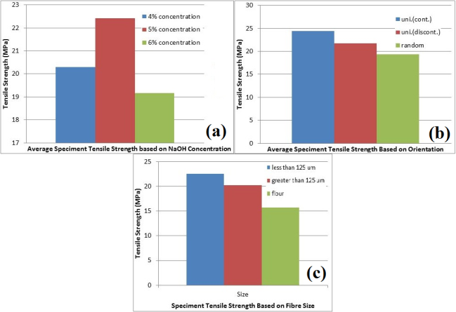
Figure 1: Average Tensile Strength based on: (a) NaOH Concentration, (b) Orientation, (c) Fibre size
For tensile test results, it shows trend that the tensile strength increase along with the fibres orientation, from flour, random distribution, discontinuous directional, and the highest was continuous directional.

It also shows trend on the same orientations, tensile strength for the fibres size less than 125$μm$ always higher than the fibres size greater than 125$μm$.

Tensile strength trends shows that increase along with the fibres orientation, from random distribution, discontinuous directional, and the highest was continuous directional and flour with 5% NaOH concentration was highest among flour fibres.

Impact Test
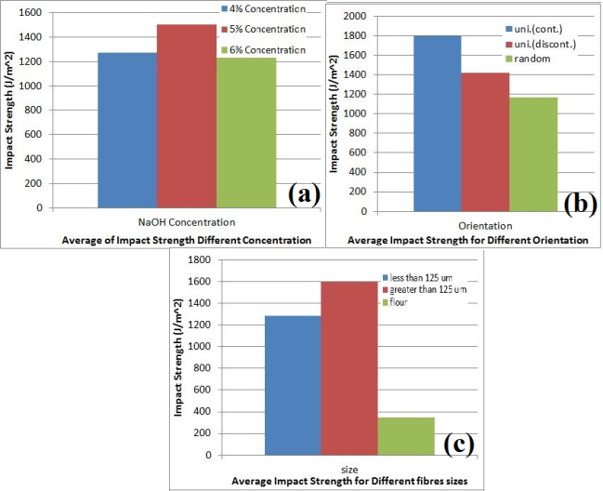
Figure 2: Average Impact Strength based on: (a) NaOH Concentration, (b) Orientation, (c) Fibre size
Impact strength shows trend that the tensile strength increase along with the fibres orientation, from flour, random distribution, discontinuous directional, and the highest was continuous directional.

It also shows trend on the same orientations, the fibres size greater than 125$μm$ always higher than the fibres size less than 125$μm$. From bar chart 20, the best orientation that gave highest tensile strength was continuous unidirectional orientation.

Impact strength shows trends increase along with the fibres orientation, from random distribution, discontinuous directional, and the highest was continuous directional and flour with 5% NaOH concentration was highest among flour fibres.

Flexural Test
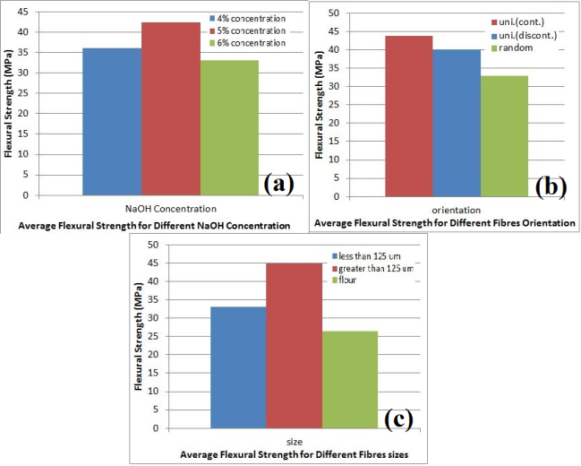
Figure 3: Average Flexural Strength based on: (a) NaOH Concentration, (b) Orientation, (c) Fibre size
Flexural strength shows trend that the tensile strength increase along with the fibres orientation, from flour, random distribution, discontinuous directional, and the highest was continuous directional.

It also shows trends on the same orientations that the fibres size greater than 125$μm$ always higher than the fibres size less than 125$μm$.

Flexural strength shows trends increase along with the fibres orientation, from random distribution, discontinuous directional, and the highest was continuous directional and flour with 5% NaOH concentration was highest among flour fibres.

Earth Degradation and Absoprtion
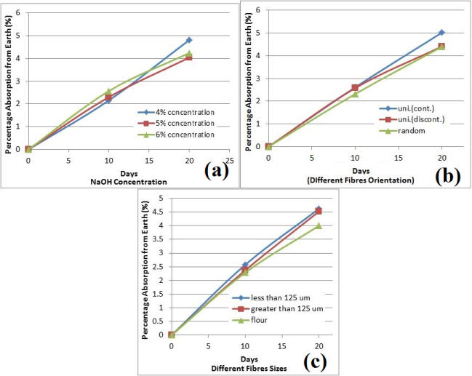
Figure 4: Average Earth Absorption Percentage based on: (a) NaOH Concentration, (b) Orientation, (c) Fibre size
For fig 4(a), earth absorption shows trend increase gradually and there is no specific trend in orientation.

For fig 4(b), earth absorption shows trend increase gradually and fibres size greater than 125 μm always higher than the fibres size less than 125 μm.

For fig 4(c) earth absorption percentage do not show any specific trend among the fibres orientation but it was increase gradually.

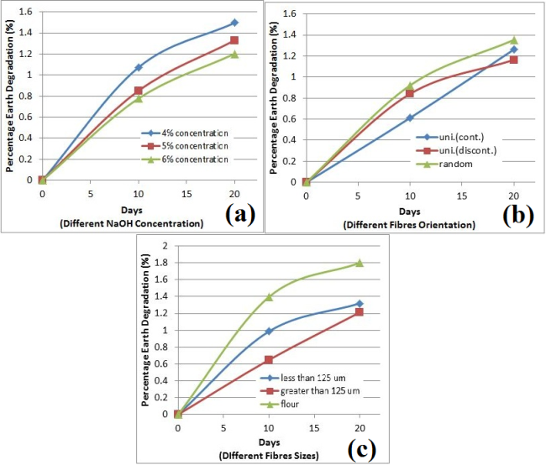
Figure 5: Average Earth Degradation based on: (a) NaOH Concentration, (b) Orientation, (c) Fibre size
From fig 5(a), it not shows any specific trend for any concentration but it shows that 4% concentration has the highest earth absorption.

From fig 5(b) and fig 5(c), no specific trend was detected. The graph shows that earth degradation percentage increase with decrease in gradient.

Water Absorption and Degradation
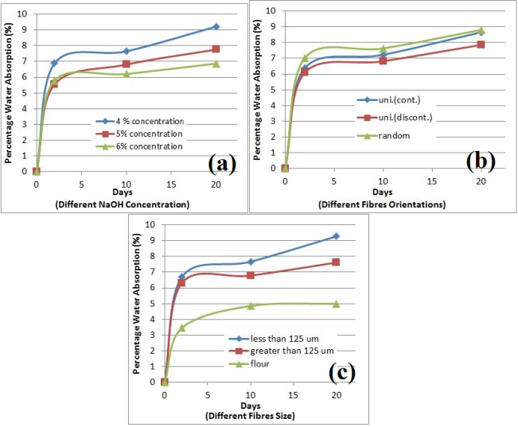
Figure 6: Average Water Degradation based on: (a) NaOH Concentration, (b) Orientation, (c) Fibre size
From fig 6, water absorption percentage shows that it exponentially increases for first 2 days and slightly increases until days 20.

From fig 6(b), water absorption percentage shows that random distribution was the highest while continuous unidirectional was lowest.

For fig 6(a), 6% has highest water absorption for first 2 days but 5% NaOH concentration show has highest water absorption percentage after 20 days.

From fig 6(c), fibres size less than 125 $μm$ has higher water absorption percentage compared to greater than 125$μm$.

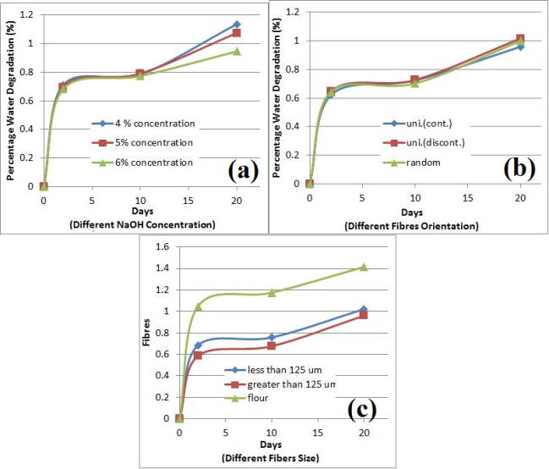
Figure 7: Average Water Degradation based on: (a) NaOH Concentration, (b) Orientation, (c) Fibre size
From fig 7, no specific trend for water degradation shows but the graph increase exponentially in first 2 days and slightly increases after that.

From fig 7(a), based on NaOH concentration it shows same trend for first 10 days but 4% concentration has highest water degradation percentage after 10 days.

From fig 7(b), based on fibres orientations, it shows trend same trend for first 10 days but discontinuous unidirectional shows highest water degradation percentage after 10 days.

From fig 7(c), flour has highest water degradation percentage and fibres size greater than 125 $μm$ was the lowest.

Scanning Electron Microscope
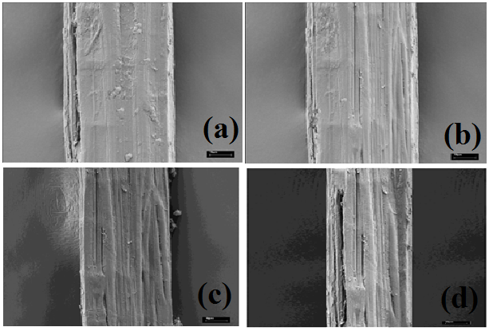
Figure 8: SEM of kenaf fibre for: (a) untreated fibre, (b) 4% treated, (c) 5% treated, (d) 6% treated
Fig 8(a) shows that untreated fibres surface was found covered with waxy substance and impurities. Fig 8(b) shows that treated with 4% NaOH concentration removed slight waxy layer and impurities from surface compared to treated with 5% NaOH concentration. Fig 8(c) shows that treated with 5% NaOH concentration shows improvement in surface morphology. It also removed waxy layer and impurities from surface. Treated fibres surface become rather rougher and fibrillation as compared to untreated fibres. Fig 8(d) shows that treated with 6% NaOH concentration make the fibres surface damaged. The surface shows degradation effects and it shows over removed waxy layer from surface.

Conclusions

From tensile test, it shows that kenaf fibres with size greater than 125$μm$, continuous unidirectional and with 5% NaOH concentration were the best. Sample 5C gives tensile strength 27.45 M Pa.

From impact test, it shows that kenaf fibres with size greater than 125$μm$, continuous unidirectional and with 5% NaOH concentration were the best. Sample 5D gives impact strength 2461.88$Jm^{-2}$. Impact strength showed a slightly increase with increase in fibres size (Yousuf A. E., 2011)

From flexural test, it shows that kenaf fibres with size greater than 125$μm$, continuous unidirectional and with 5% NaOH concentration were the best. Sample 5D gives flexural strength 57.85 M Pa.

From earth degradation test, it shows that fibres with size greater than 125$μm$, random distribution and with 5% NaOH concentration were the lowest earth absorption percentage. At day 20, sample 5F gives lowest earth absorption percentage, 2.92%. For earth degradation, it shows that fibres with size less than 125$μm$, discontinuous unidirectional with 6% NaOH concentration was the lowest earth degradation percentage. At day 20, sample 6B gives lowest earth degradation percentage, 0.75%.

From water absorption and degradation, it shows that fibres with flour size and with 4% NaOH concentration were the lowest water absorption percentage. At day 20, sample 4% FLOUR gives lowest water absorption percentage, 4.39%. For water degradation, it shows that fibres with size less than 125$μm$, discontinuous unidirectional and with 6% NaOH concentration were the lowest water degradation percentage. At days 20, sample 6B gives lowest water degradation percentage, 0.80%.

Treatment of kenaf fibres improve the interfacial adhesion of the fibres with the matrix and significantly improved the tensile, impact and flexural properties of Kenaf Fibre Reinforced Composite. From Scanning Electron Microscopic, it shows that treated kenaf fibres with 5% Sodium Hydroxide was the best surface observation and it removed waxy layer and improve impurities compare to untreated. Very high concentration of NaOH would certainly damage the fibres and consequently reduce the tensile strength of the fibres (L.Mwaikambo, 2002).

References
Aziz S. H., A. M. P. C. S. J. P. S. R., 2005. Composite Science Technology. Issue 65, p. 525.
B.F. Yousif, A. S. C. C. K. M., 2012. Flexural properties of treated and untreated kenaf/epoxy composites. Materials and Design, Volume 40, p. 378–385.
Chen L., C. E. P. P. J. F. M. J. B. J. G., 1995. Proc. Int. Kenaf Assoc. Conf. Irving. p. 15—23.
D. NABI SAHEB, J. P., 1999. Natural Fiber Polymer Composites: A Review. Advances in Polymer Technology, 18(4), p. 351–363.
Dansiri N., Y. N. E. J. W. I. H., 2002. Polym. Compos., Issue 23, p. 352.
Edeerozey AMM, A. H. A. A. A. M., 2007. Chemical modification of kenaf fibres. Mater Lett, Issue 61, pp. 2023-2025.
George J., S. M. T. S., 2001. A review on interface modification and characterization of natural fiber reinforced plastic composites. Polymer Engineering & Science, 49(9).
Groover, M. P., 2004. Fundamental of Modern Manufacturing. 2nd ed. Inc, 111 River Street, Hoboken, NJ: John Wiley & Sons,.
Holbery. J, H. D., 2006. Natural-Fibres-Reinforced Polymer Composites in Automotive Applications. JOM, 58(11), pp. 80-86.
I.S. Aji, S. S. E. Z. a. K. A., 2009. KENAF FIBRES AS REINFORCEMENT FOR POLYMERIC COMPOSITES: A REVIEW. International Journal of Mechanical and Materials Engineering (IJMME), Volume 4, pp. 239-248.
Jamaludin, J. B., 2008. Effects of Fiber Size Modification on The Mechanical Properties of Kenaf Fibre Reinforced Polyester Composite, s.l.: UNIVERSITI TEKNIKAL MALAYSIA MELAKA.
Karnani R., K. M. N. R., 1997. Polymer Engineering Science, Issue 37, p. 476.
L.Mwaikambo, M. A., 2002. Chemical modification of hemp, sisal, jute and kapok fibers by alkalization. Applied Polymer Science, 84(12), pp. 2222-2234.
Lee, B. H. K. H. J. a. Y. W. R., 2009. Fabrication of Long and Discontinuous Natural Fibres Reinforced Polypropylene Biocomposites and Their Mechanical Properties. Fibres and Polymers, Volume 10, pp. 83-90.
Li X, T. L. P. S., 2007. Chemical treatments of natural fibres for use in natural fibres-reinforced composites. Polymer Environment, Issue 15, pp. 25-33.
Li Y., H. C. Y. Y., 2008. Interfacial studies of sisal fiber reinforced high density polyethylene (HDPE) composites. Composites Part A, 39(4), p. 570–578.
Malkapuram R., K. V. Y. S. N., 2008. Recent Development in Natural Fibre Reinforced Polypropylene Composites. Journal of Reinforced Plastics and Composites, Volume 28, pp. 1169-1189.
Malkapuram, R. K. V. Y. S. N., 2008. Recent Development in Natural Fibres Reinforced Polypropylene Composites,. Journal of Reinforced Plastics and Composites, Volume 28, pp. 1169-1189.
Nimmo B., 2002. “Kenaf Fibers”, Presentation of the 5th Annual Conference of the American Kenaf Society. Memphis, TN.
O.M.L. Asumani, R. R. R. P., 2012. The effects of alkali–silane treatment on the tensile and flexural properties of short fibres non-woven kenaf reinforced polypropylene composites. Composites: Part A, Issue 43, p. 1431–1440.
Oksman K., S. M. S. J. F., 2003. Natural fibres as reinforcement in polylactic acid (PLA) composites. Composites Science and Technology, 63(9), pp. 1317-1324.
R. Byron Pipes, R. L. M. D. G. T., 1982. Behavior of Discontinuous Fiber Composites: Fiber Orientation.. POLYMER COMPOSITES, 3(1).
Ramaswamy G. N., R. C. G., 1995. Boyd C. Sci. Res. J, 2 (24), p. 180.
Ribot, N. A. Z. M. N., April 2011. MECHANICAL PROPERTISE OF KENAF FIBRES COMPOSITE USING CO-CURED IN-LINE FIBRES JOINT. International Journal of Engineering Science and Technology, 3(4), pp. 3526-3534.
Saha P et al, 2010. Enhancement of tensile strength of lignocellulosic jute fibers by alkali-steam treatment. Bioresource Technology, 9(101), p. 3182–3187.
Seong, T. K., 2002. REINFORCED PLASTIC COMPOSITES: KENAF (HIBUSCUS CANNABUNUSL.). FIBRES- POLYPROPYLENE BLEND..
Shibata S, C. Y. F. I., 2008. Flexural modulus of the unidirectional and random composites made from biodegradable resin and bamboo and kenaf fibres. Compos A Appl Sci Manuf , 39(4), p. 6406.
Sikarwar, R. S. R. V. V. M., 2012. "Experimental and analytical study of high velocity impact on Kevlar/Epoxy composite plates". Central European Journal of Engineering, 2(4), p. 638–649.
Van de Weyenberg I, I. J. D. C. A. K. B. B. E. V. I., 2003. Influence of processing and chemical treatment of flax fibres on their composites. Compos Sci Technol, Issue 63, pp. 1241-1246.
Yousuf A. E., S. M. S. K. A. Z. E. S., 2011. Development Of a New Kenaf Bast Fibres-Reinforced Thermoplastic Polyethane Composite. “Kenaf bast-TPU composite”. BioResources , Issue 6(4), pp. 4662-5672.

