Preliminary Studies on Mechanical Behavior of Natural Fiber Reinforced Polymer Composites

K.Gopalakrishnan
Department Of Mechanical Engineering
R.M.K Engineering College
Chennai. India
krishgopz@gmail.com
S.Gokulakrishnan
Department Of Mechanical Engineering
R.M.K Engineering College
Chennai, India
gokulksn@gmail.com

Abstract—World is as of now concentrating on alternate material sources that are environment agreeable and biodegradable in nature. Because of the expanding natural concerns, bio composite produced out of regular fiber and polymeric resin is one of the latest advancements in the business and constitutes the present extent of experimental work. The use of composite materials field is increasing gradually in engineering. The composite consists of mainly two phases i.e. matrix and fiber. The accessibility of characteristic fiber and simplicity of assembling have enticed scientists worldwide to attempt by regional standards accessible inexpensive fiber and to learn their achievability of fortification determinations and to what degree they fulfill the obliged of great strengthened polymer composite aimed at structural requisition. Fiber reinforced polymer composites has numerous preferences, for example a minimal effort for creation, better quality contrast than perfect polymer tars. Due to these reasons, fiber strengthened polymer composite utilized within an assortment of provision as class of structural material. This work describes the mechanical behavior of banana fiber reinforced polymer composite with extraordinary references to the impact of fiber loading and the length of fiber on the properties of composite in mat form.
Index Terms—Natural fiber reinforced composites

Introduction
The attraction in utilizing natural Fiber, for example, distinctive wood Fiber and plant Fiber as support in plastics has expanded drastically throughout last few years. Concerning the ecological viewpoints if natural Fibers might be utilized rather than glass Fibers as fortification in some structural provisions it might be extremely intriguing. Natural Fibers have numerous points of interest contrasted with glass Fiber, for instance, they have low thickness, and they are biodegradable and recyclable. Also they are renewable crude materials and have generally great strength and stiffness. Natural Fibers are classified on the basis of the origin of source, into three types

- Plant Fibers
- Mineral Fibers
- Animal Fibers
1. Plant Fibers: Plant Fibers are usually consists of cellulose: examples cotton, jute, bamboo, flax, ramie, hemp, coir and sisal. Cellulose Fibers are used in various applications. The category of these Fibers is as following: Seed Fibers are those which obtain from the seed e.g. Kapok and cotton. These Fibers having superior tensile properties than the other Fibers. Because of these reason these Fibers are used in many applications such as packaging, paper and fabric. Fruit Fibers are the Fibers generally are obtain from the fruit of the plant, e.g. banana Fiber and coconut Fiber. Similarly, stalk Fiber are the Fibers which are obtain from the stalks (rice straws, bamboo, wheat and barley). Leaf Fibers are the Fibers those are obtain from the leaves (agave and sisal). Skin Fibers are those Fibers which are obtaining from the bast or skin surrounding the stem of the plant.

2. Mineral Fibers: Mineral Fibers are those which are getting from minerals. These are naturally happening Fiber or somewhat changed Fiber. It has different classifications they are taking after: Asbestos is the main characteristically happening mineral Fiber. The Variations in mineral Fiber are the serpentine, amphiboles and anthophyllite. The Ceramic filaments are glass Fiber, aluminum oxide and boron carbide. Metal filaments incorporate aluminums strands.

3. Animal Fibers: Animal Fiber by and large comprises of proteins; cases, silk, alpaca, mohair, downy. Animal hairs are the strands got from creatures e.g. Sheep's downy, goat hair, horse hair, alpaca hair, and so forth. Silk Fiber is the filaments gathered from dry saliva of bugs or creepy crawlies throughout the time of planning of cocoons. Avian strands are the Fiber from fowls [1]. Composites of natural Fiber used for drives of structural, but typically with synthetic thermoset matrix which of course bound the environmental benefits. Now a days natural Fiber composites application are usually found in building and automotive industry and the place where dimensional constancy under moist and high thermal conditions and load bearing capacity are of importance[2,3]. Natural Fibers like cotton, sisal, jute, abaca, pineapple and coir have already been studied like a reinforcement and filler in composites. Among various natural Fibers, banana Fiber is considered as a potential reinforced in polymer composites due to its many advantages such as easy availability, low cost, comparable strength properties etc. Generally, natural Fibers are consists of cellulose, lignin, pectin etc. The detail composition of few commonly used natural Fibers are shown in Table 1.1
Table 1.1 Composition of few commonly used natural Fibers
Fiber | Cellulose  (wt %) | Hemicellulose  (wt%) | Lignin  (wt%) | Pectin  (wt%)
Cotton | 85-90 | 5.7 | - | 0-1
Bamboo | 60.8 | 0.5 | 32 | -
Flax | 71 | 18.6-20.6 | 2.3 | 2.2
Hemp | 70-74 | 17.9-20.4 | 3.7-5.7 | 0.9
Jute | 61.1-71.5 | 13.6-20.4 | 12-13 | 0.2
Kenaf | 45-47 | 21.5 | 8-13 | 3-5
Ramie | 68.6-76.2 | 13.1-16.7 | 0.6-0.7 | 1.9
Sisal | 66-78 | 10-14 | 10-14 | 10
Coir | 32-43 | 0.15-0.25 | 40-45 | 3-4
Banana | 63-64 | 19 | 5 | -
The composite materials could be termed as those materials which are synthesized by two or more materials having diverse properties. By and large, composites materials have strong load carrying reinforcing material imbedded in weaker lattice materials. The primary constituent of composites have a nonstop stage which is the significant a piece of the composite is called matrix. Matrix are by and large more ductile and less hard and these are generally either inorganic or natural. Optional constituent of composites have ductile called reinforcement and they are implanted in the matrix. The constituents of composite materials have their property however when they are consolidated together, they give a blend of properties that a singular can't have the capacity to give. Generally, composite materials are arranged on the basis of matrix materials as:
  - Ceramic Matrix Composites
  - Polymer Matrix Composites
  - Metal Matrix Composites

Ceramic matrix composite: The composite which is consisting of a ceramic combined with a ceramic dispersed phase. Because of availability of new technologies, the demand for high performance products and processing methods, have together improve the growth of advanced ceramic products, but brittleness of ceramics still retain a major disadvantage.

Polymer matrix composite: Polymer matrix composites are recognized to be a more conspicuous class of composites when contrasted with artistic or metal lattice composites once in business requisitions. It includes a matrix from thermoplastic (polystyrene, nylon) or thermosetting (urea formaldehyde, unsaturated polyester) or and inserted steel, glass carbon, or Kevlar strands.

Metal matrix composite: Composites consisting of metal matrix such as Mg, Al, Fe is called metal matrix composites. The interest in metal matrix composites is due to many reasons such as their engineering properties. They are of exhibit good stiffness, light weight, and low specific weight as compared to other metal alloys and metals. Although it has many advantages, low cost remains a major point of interest for many applications. Among these all types of composites, polymer matrix composite is most commonly used composites, because of its advantages such as high strength, low cost, simple manufacturing principle. The requirement of polymer material in this modern dynamic world is increasing day by day because it has wide range of advantages over traditional material in terms of high strength to weight ratio, cost, high toughness, high tensile strength, and high creep resistance at increases in temperatures. Polymer matrix composites have three types of polymer which have been used as matrix. These are thermoplastics, thermosetting and elastomeric polymer. Thermoplastic polymer is that polymer which are over and again diminished and transformed by heating. A few illustrations of thermoplastics are PVC, LDPE, and HDPE. Thermoplastic materials are shaped when they are in softened or melted. Thermoplastic have numerous properties, for example, lightweight, low thickness which is relying on science they could be similar to elastic and strong as aluminum. Thermosetting polymer is the polymer which has hard and firm cross-interfaced materials. They are not moldable when and soften when they are warmed. Epoxy is the most normally utilized thermosetting polymer. They have numerous advantages, for example, better grip to different materials, great mechanical properties, and great electrical protection. Elastomer is a kind of polymer is determined from flexible polymer, is frequently utilized reciprocally with the term elastic, despite the fact that the last is favored when alluding to vulcanizes. Elastomers have numerous properties which having low density and high disappointment strain compare with other material. The other sort of constituents of composites is reinforcements. Reinforcements are generally used to upgrade general mechanical properties of matrix and offer quality to composites. The reinforcement in composites is either fibrous or non-fibrous. Again fibrous composites are either natural Fiber reinforced or synthetic Fiber reinforced composites. There are many factors affecting the properties of Fiber reinforced polymer composites such as Fiber parameters, matrix Fiber-matrix interfacial bonding etc. A great deal of work has been done on the different kinds of natural Fiber based polymer composites [5]. The objective of the present work is to study the potential utilization of banana Fiber as a reinforcing material in epoxy composites and to investigate their mechanical behavior.

Literature Survey
This chapter outlines some work and report available in past related to mechanical properties of natural Fiber based polymer composites with unique consideration on banana Fiber based polymer composites. The mechanical behavior of a natural Fiber based polymer composite depends on numerous factors, for example, Fiber length and quality, matrix, Fiber-matrix adhesion bond quality and so forth. The strong interface bond between Fiber and matrix is paramount to show signs of improvement mechanical properties of composites. Merlini et al. [6] have studied the effect surface treatment on the chemical properties of banana Fiber and reported that treated banana Fiber give higher shear interfacial stress and tensile strength when compared with the untreated Fibre.and based on the paper on effects of resin inside Fiber lumen on the mechanical properties of sisal Fiber reinforced composites Li Yan , Ma Hao , ShenYiou , Li Qian , Zheng Zhuoyuan shows that mat type natural fiber has better properties compared to other forms of fiber. Dhieb et al. [7] have studied about the surface and sub-surface degradation of unidirectional carbon Fiber and have given many conclusion such as under sliding demineralized water, the most simple degradation was detected on sliding in anti-parallel direction. Shankar et al. [8] have studied and reported that the ultimate tensile strength value maximum at 15% and then decreases with increasing in Fiber starting from 15% to 20%. They also reported that the flexural strength value decreasing from 5% to 10% (87.31 MPa) and after that the value increased from Fiber. Sumaila et al. [9] have investigated the influence of Fiber length on the mechanical and physical properties of nonwoven short banana, random oriented Fiber and epoxy composite and they described that the tensile properties and percentage elongation of the composite attained a maximum in composite fabricated from 15 mm Fiber length. They have also reported that the impact energy whereas the compressive strength increases decreased with increasing Fiber length, also the mean flexural properties of the composite increased with increasing in Fiber length up to 25mm. The banana Fibers characteristic depending on the variation of diameter, mechanical characteristic and the effects of the tresses performing on the fracture morphology. The stress-strain curves for changed strain rates were found and fractured surfaces were inspected by SEM [10]. Pothan et al. [11] have investigated on the influence of Fiber content and length on short banana Fiber reinforced polyester composite material. Laban et al. [12] has studied on the physical and mechanical behavior of banana Fiber reinforced polymer composite and noticed that kraft mashed banana Fiber material has better flexural strength. The tensile strength is detected maximum at 30 mm Fiber length whereas the impact strength is noticed maximum at 40 mm length of Fiber. Consolidation of 40% untreated banana Fibers gives 20% rise in the tensile strength and 34% rise in impact strength. Prasannaand Subbaiah [13] reported that composites material having 20% treated Fiber loading possess maximum values for above-mentioned properties than untreated composites, 10% and also 30% treated Fibers composites. The interfacial area having main role in influential the strength of polymer material since Fiber procedures a separate interface with the matrix. The effects of this study uncovered that short zigzag Fiber composites with great rigidity and element mechanical properties might be effectively ready utilizing banana Fiber as reinforcement in a polyurethane matrix inferred from castor oil. The treated banana Fiber demonstrated higher shear stress and tensile strength when contrasted with the untreated Fiber, showing a solid association between the treated strands and the polyurethane matrix [6]. The hybridization of these reinforcement in the composite shows more terrific flexural quality when contrasted with singular kind of characteristic strands strengthened composites. All the composites shows expand in flexural quality in longitudinal heading. Comparable patterns have been watched for flexural modulus, entomb laminar shear quality and break burden values [14]. There are many researches who have evaluated the mechanical, chemical and physical behavior and banana Fiber reinforced with epoxy composite. Many studied and compared of effect of treated and untreated banana Fiber reinforced with thermoplastic and thermosetting polymer [15-19]. Joseph et al. [20] studied and compared the mechanical behavior of phenol formaldehyde composites which was reinforced with glass Fiber and banana Fiber. Selzer and Friedrich et al. [21] studied the carbon Fiber reinforced polymer composites and reported that the brittle materials demonstrate a lot of delimitation’s also interlinear splitting throughout weariness. The disappointment of this material was dictated by a restriction of disappointment. This implies that in composites with an exceptionally intense grid and great Fiber-network bond, various splitting, which ingests a higher measure of vitality, is anticipated, with the goal that at last confined disappointment happens at easier levels than anticipated. There is wide range of research in these fields; many researchers have investigated the natural Fiber composite reinforced with various type of polymer [22-24]. The banana and glass Fiber bio-composites may be fabricate for outdoors and indoors applications wherever high strength is not necessary, additionally it can considered as the replacement to wood materials and protect the forest resources [25]. Malequeet al. [26] have studied the mechanical properties of banana Fiber based epoxy composite and it was observed that the tensile strength is increased by 90% of the pseudo-stem banana Fiber reinforced epoxy composite associated to virgin epoxy. In his results the impact strength of pseudo-stem banana
- Fiber improved by approximately 40% compare to the impact strength of neat epoxy. The impact strength value is higher which indications to higher toughness value of the material. They are also reported that when banana woven Fiber was used with epoxy material then the flexural strength increased. There are many reports available on the mechanical and physical properties of natural Fiber reinforced polymer composites, but, the effect of Fiber length on mechanical behavior of banana Fiber reinforced polymer composites is scarcely been reported. To this end, the current work has undertaken with the objectives to investigate the mechanical properties of banana Fiber based epoxy composite

MATERIALS AND METHODS
This chapter consists of two parts
- Details of processing of the specimen preparation.
- Testing of mechanical properties of composites
The materials used are:
    - Banana Fiber
    - Epoxy
    - Hardener
3.1. Specimen Preparation Method

The banana Fiber (Figure 3.1) is obtained from banana plant, which has been collected from local sources. The extracted banana Fiber were subsequently sun dried for eight hours then dried in oven for 24 hours at 105° C to remove free water present in the Fiber. The dried Fiber was subsequently cut into lengths on based on ASTM Standards of 300mmx300mm. The epoxy resins and hardener are procured from MIT. The banana Fiber based epoxy resin composite is fabricated using hand lay-up process. The moulds have been prepared with dimensions of 180×180×40 mm³. The prepared mat form banana Fiber has been mixed with matrix mixture with their respective values by simple mechanical stirring and mixture are slowly poured in different moulds, keeping the characterization standards and view on testing condition. The releasing agent has been use on mould sheet which give easy to composites removal from the mould after curing the composites. A sliding roller has been used to remove the trapped air from the uncured composite and mould has been closed at temperature 30° C duration 24 hour. The constant load of 50 kg is applied on the mould in which the mixture of the banana, epoxy resin and hardener has been poured. After curing, the specimen has been taken out from the mould. The composite material has been cut in suitable dimensions with help of zig saw for mechanical tests as per the ASTM standards. The fabricated short banana Fiber based epoxy composite is shown in Figure 3.1.
Figure3.1 Fabrication of composite
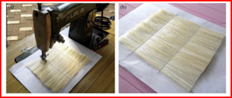
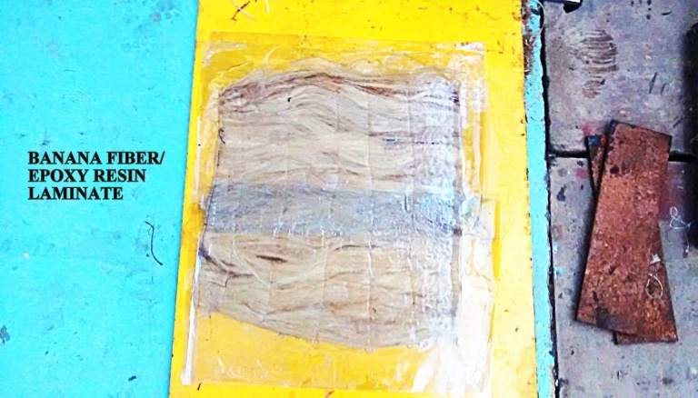

TESTING OF MECHANICAL PROPERTIES OF COMPOSITE
Flexural Strength Test
Specimen dimension for flexural test was 150 mm × 4.2 mm × 10 mm and three point bend test method was used for finding the flexural strength using Universal Testing Machine Tinus Olsen. The loading arrangement for flexural strength is shown in Figure 3.2
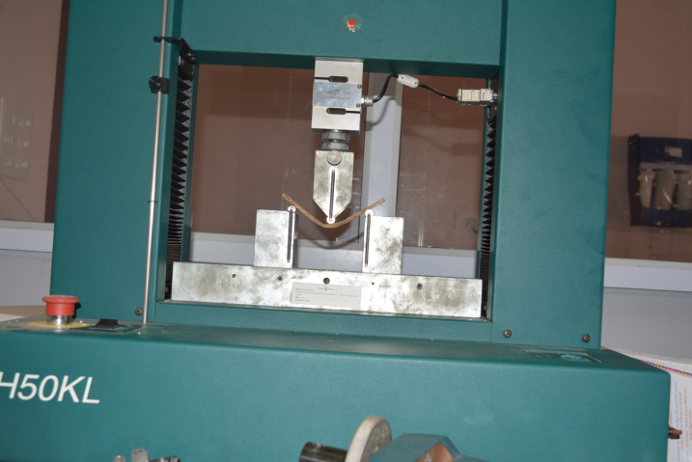
Figure 3.2 Experimental set up for flexural strength
Tensile Strength Test
Fabricated composite was cut to get the desired dimension of specimen for mechanical testing. For the tensile test, the specimen size was 105mm² and gauge length was 150 mm. Tensile strength was tested in Tinus Olsen. The specimen with desired dimension was fixed in the grips of the Instron machine with 7 mm gauge length. The experimental set up for tensile test is shown in Figure 3.3
Figure 3.3 Tensile Test
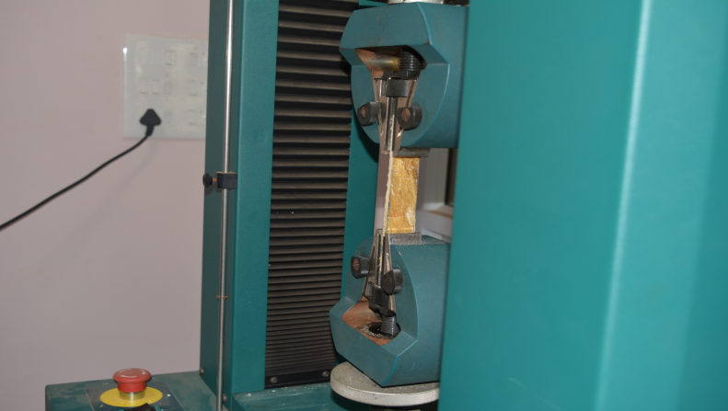
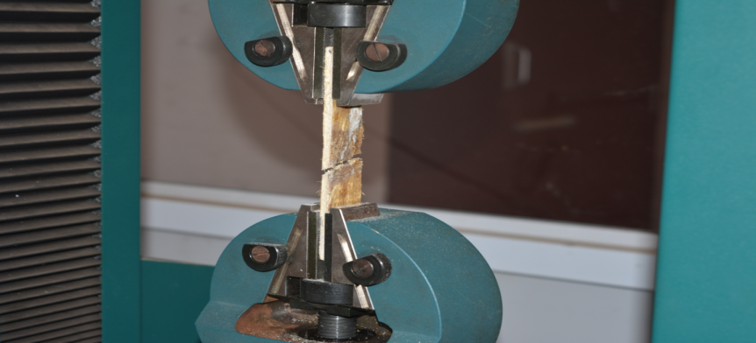

VI. RESULTS AND DISCUSSIONS
This chapter deal with mechanical properties of the banana Fibre based epoxy composites.
Mechanical Properties of Composites
Mechanical properties of composites such as flexural strength, tensile strength, hardness and impact strength has been investigated and also discussed. The mechanical properties of the composite are mainly depending on many factors such as Fibre content and length influence of Fibre Parameters on Flexural Strength
Influence of Fibre Parameters on Flexural Strength
The influence of Fibre length and loading on flexural strength of fabricated composites is shown in In figure it is show that when the load increases the flexural strength of the fabricated composites first increases up to 10 mm length and then decreases. Hence, we can conclude the composite shows considerable amount of flexural strength under the loading. 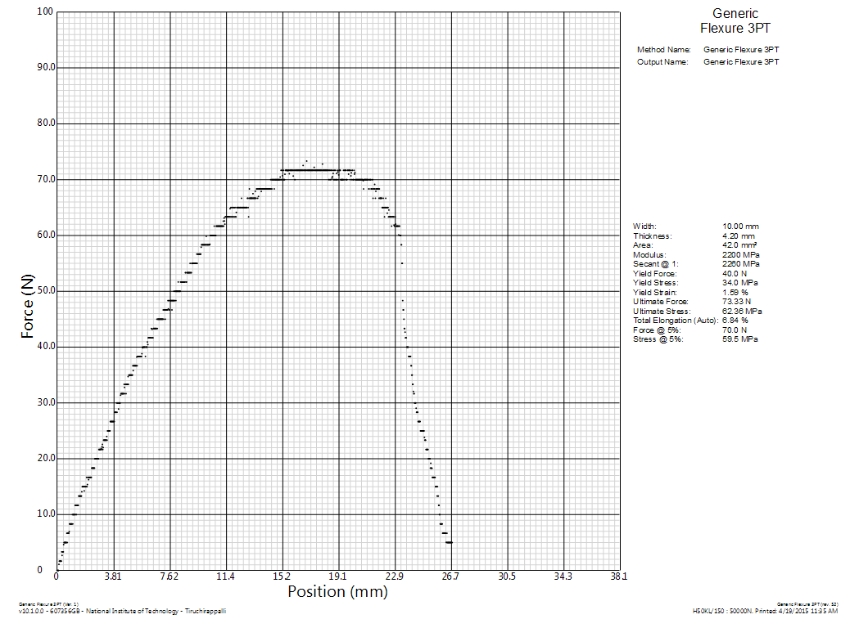
Figure 4.1 Influence of fiber parameters on flexural strength of composites

Influence of Fibre Parameters on Tensile strength
The mechanical behaviour of the banana Fibre based epoxy composites depends on Fibre parameters. The influence of Fibre length and loading on tensile properties of composites is shown in. It has been observed that the tensile strength of composites increases with increase in Fibre length and loading. 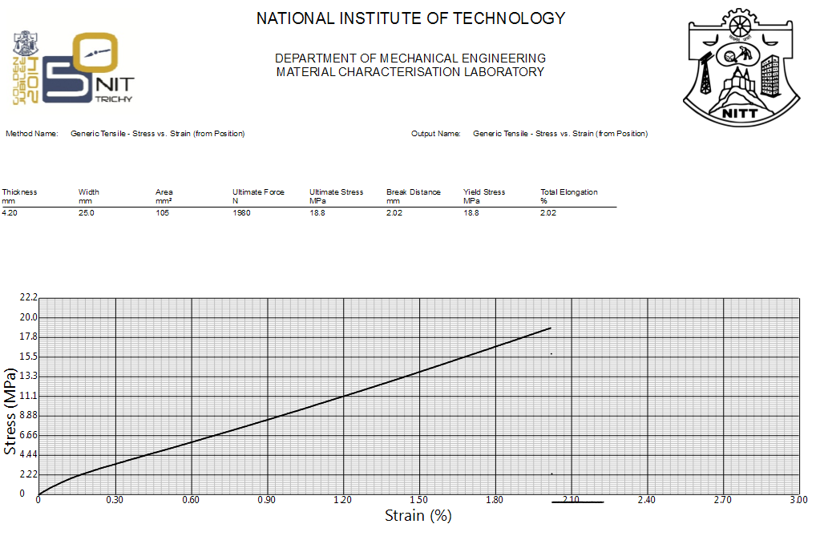
Figure 4.2 Bending test along the axial direction

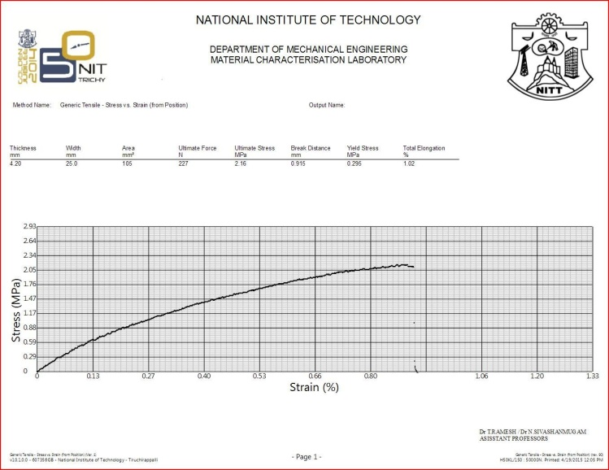
Figure 4.3 Bending test on fiber along transverse direction

CONCLUSIONS

This experimental examination of mechanical behavior of banana Fiber (mat form) based epoxy composites indicate to the many conclusions:
1. The fabrication of banana Fiber (mat form) epoxy based composites with different loading of Fiber and different lengths of Fiber are possible by hand lay-up process.
2. From the current experiments results, it has been observed that for various Fibers loading mat form type natural banana Fiber composite shows better results than the other types such as chopped type, uni- directional type, and major effect on the mechanical properties of the composites like as hardness, tensile strength and flexural strength.
3. Hence, this work concludes that natural banana Fiber-epoxy resin composite (mat type) shows better than other conventional types.

References
- Shankar P. S., Reddy K.T., Sekhar V. C., Mechanical Performance and Analysis of Banana Fibre Reinforced Epoxy Composites, International Journal of Recent Trends in Mechanical Engineering, Vol. 1, 2013, pp.1-10.
- Sumaila M., Amber I., Bawa M., Effect of Fiber Length on the Physical and Mechanical Properties of Random Oriented, Nonwoven Short banana (Musa Balbisiana) Fiber/Epoxy Composite, Asian Journal of Natural & Applied Sciences, 2 (2013), pp. 39-49.
- Satyanarayana K. G., Sukumaran K., Pavithran C., Mukherjee P. S., Pillai S. G. K., Natural Fibre-Polymer Composites, Cement and Concrete Composites, 12 (1990), pp. 117-136.
- Kulkarni A. G., Rohatgi P. K., Satyanarayana K. G., Sukumaran K., Pillai S. G. K., Fabrication and Properties of Natural Fibre-Reinforced Polyester Composites, Composites, 17 (1986), pp. 329-333.
- Dhieb H., Buijnsters J. G., Eddoumy F., Vázquez L., Celis J.P., Surface and Sub-Surface Degradation of Unidirectional Carbon Fibre Reinforced Epoxy Composites Under Dry and Wet Reciprocating Sliding, Composites Part A: Applied Science and Manufacturing, 55 (2013), pp. 53–62.
- Merlini C., Soldi V. , Barra G. M. O., Influence of Fibre Surface Treatment and Length on Physico-Chemical Properties of Short Random Banana Fibre-Reinforced Castor Oil Polyurethane Composites, Polymer Testing, 30 (2011), pp. 833–840.
- Li Yan , Ma Hao, ShenYiou, Li Qian, ZhengZhuoyuan., Effects of resin inside Fibre lumen on the mechanical properties of sisal Fibre reinforced composites. Composites Science and Technology 108(2015) 32-40.

